[www.oracle.com/academy](http://www.oracle.com/academy)

Database Programming with SQL 18-1: Regular Expressions Practice Solutions

# Vocabulary

Directions: Identify the vocabulary word for each definition below

|  |  |
| --- | --- |
| **Commit** | Ends the current transaction by discarding all pending data  Changes |
| **Rollback** | Enables the user to discard changes made to the database |
| **Savepoint** | Creates a marker in a transaction, which divides the transac- tion into smaller pieces |
| **Read con-**  **sistency** | guarantees a consistent view of the data by all users at all  times |
| **Locks** | Mechanisms that prevent destructive interaction between transactions accessing the same resource that can be granted to the user |
| **Transaction** | a collection of DML statements that form a logical unit of work |

# Try It / Solve It

1. Define the COMMIT, ROLLBACK, and SAVEPOINT statements as they relate to data transactions.

## Solution:

**COMMIT:** changes written to database

**ROLLBACK:** undoes changes that have not been committed to the database

**SAVEPOINT:** a marker in a transaction, which breaks the transaction into smaller parts.

1. What data will be committed after the following statements are issued?

INSERT INTO R values (5, 6);

SAVEPOINT my_savepoint_1; INSERT INTO R values (7, 8);

SAVEPOINT my_savepoint_2; INSERT INTO R values (9, 10);

ROLLBACK TO my_savepoint_1; INSERT INTO R values (11, 12); COMMIT;

## Solution:

Only (5,6) and (11,12) are committed.

1. Construct a SQL statement for the DJs on Demand D_SONGS table that deletes the song “All These Years,” inserts a new Country song called ‘Happy Birthday Sunshine’ by “The

2

Sunsets” with a duration of 4 min and an ID = 60. Make sure that all data can be recovered before any changes to the table are made.

## Solution:

SAVEPOINT one ;

DELETE FROM d_songs WHERE title = 'All These Years' ;

INSERT INTO D_SONGS(id, title, duration, artist, type_code) VALUES(60, 'Happy Birthday Sunshine', '4 min', 'The Sunsets', 88);

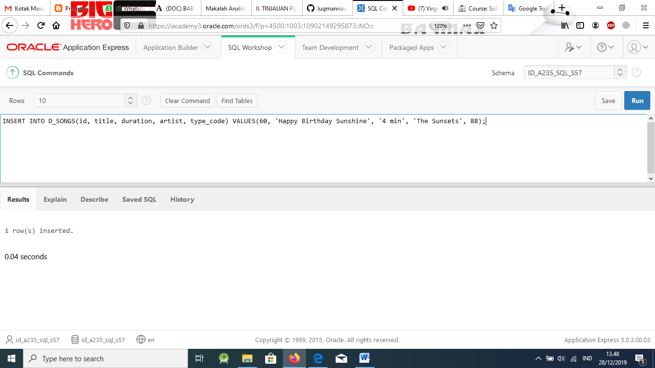

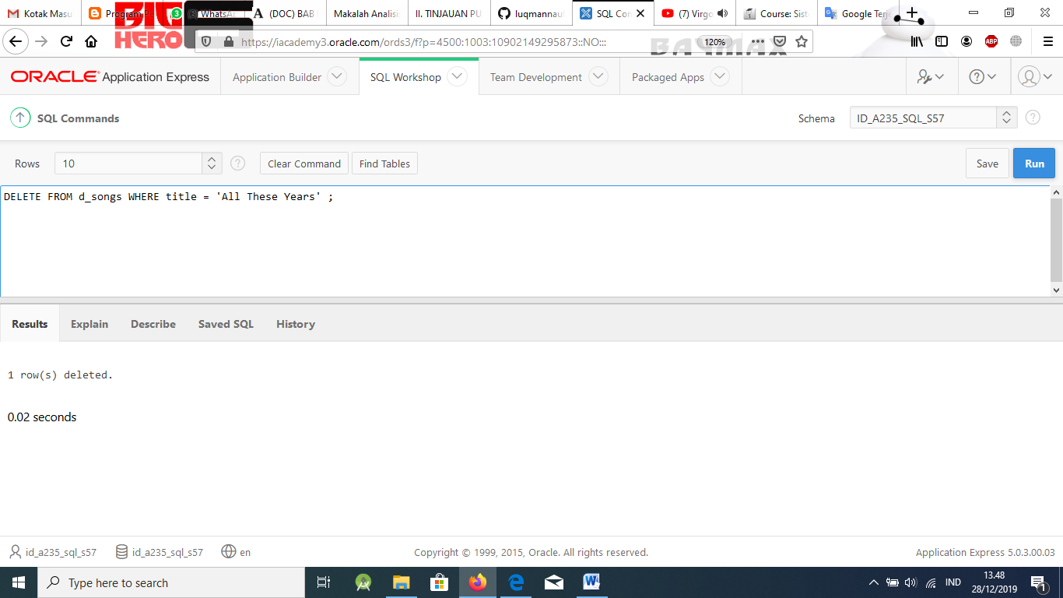

1. Write an SQL statement that will issue an automatic commit.

## Solution:

Any DDL or DCL statement, or if the system fails.

1. Give two examples of business other than banks that rely on transaction control processes. Describe why each business needs transaction processing control.

## Solution:

Grocery stores and department stores constantly make updates to items in inventory. They also delete items that don’t sell and add new items. These processes require many DML statements. It would be essential for the database entry personnel to be able to quickly correct mistakes or to be able to withdraw entries if merchandise was not available as anticipated.

Online businesses such as eBay use a delayed pay system to guarantee buyer satisfac- tion before payments are made. With millions of transactions, it would be essential to be able to control each transaction.